

|  |
| --- |
| Fuzzy Pattern  Recofnition |
|  |
| December 8  [Saeed77t@gmail.com](mailto:Saeed77t@gmail.com) / student number: 40160957  Authored by: Reza Tahmasebi |



Table of Contents

Clustering method based on fuzzy equivalence relations and pattern recognition 3

How codes work 3

Use PCA 3

Rfunc function : 3

Use Rfunc: 3

RoR function : 4

calcAlphacut function: 5

# Clustering method based on fuzzy equivalence relations and pattern recognition

The goal of this homework is to cluster some data based on how much they are similar to each other.

# How codes work

First, the data has been read with the *loadmat* method from the *mat4py library. After* that, the data was divided into two sections the *digits* and the *labels.*

## Use PCA

*PCA* method from *sklearn* library used to extract features from data.

## Rfunc function :

This function gets X1, X2 and q as arguments, and it will return the distance of two data

And it implements the formula bellow

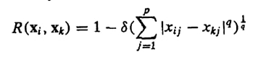

This function returns the distance between two data.

## Use Rfunc:

In two nested for loops with the length of our data (150), the Rfunc is called. And it created a fuzzy compatibility relation in our data.

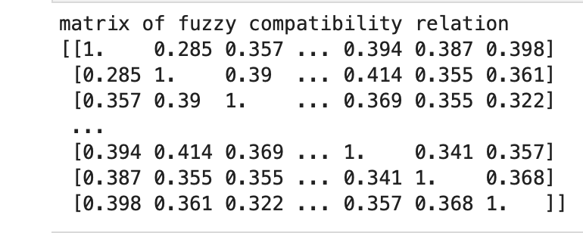

The figure above is a model of compatibility relation.

## RoR function :

This function gets the table that was created with Rfunc as an argument and, with the algorithm below, returns the matrix of transitive closure.

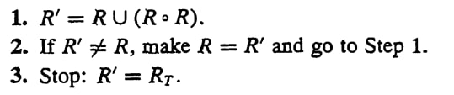

This function uses 3 for loops and a while loop to create the matrix of transitive closure, so it has enormous computational complexity.

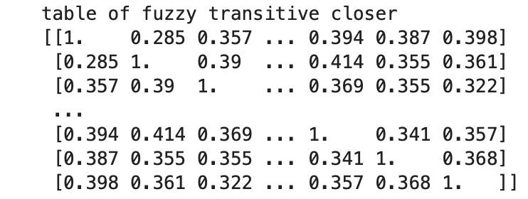

The table above is the matrix of transitive closure that the RoR function created.

## calcAlphacut function:

This function gets the value of the alpha cut and the data as arguments and prints the clustering values.

The function uses the alpha cut value as a threshold and splits the data into parts.

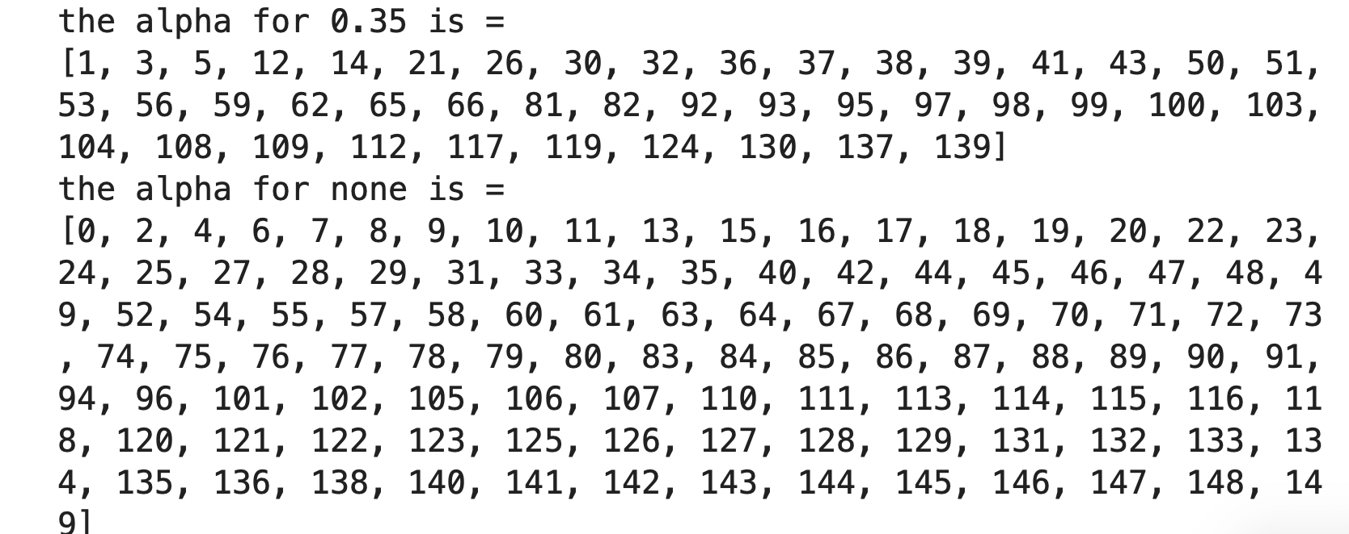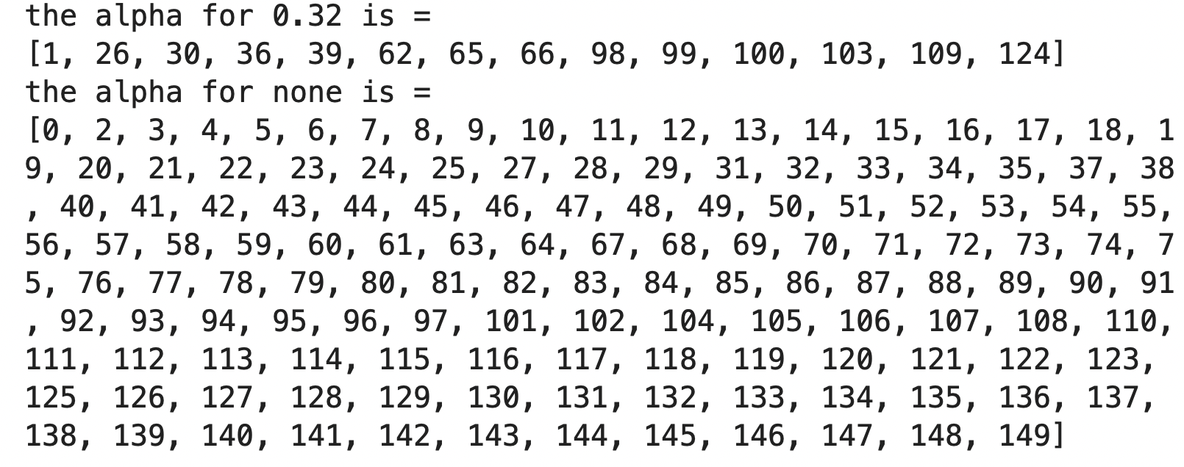

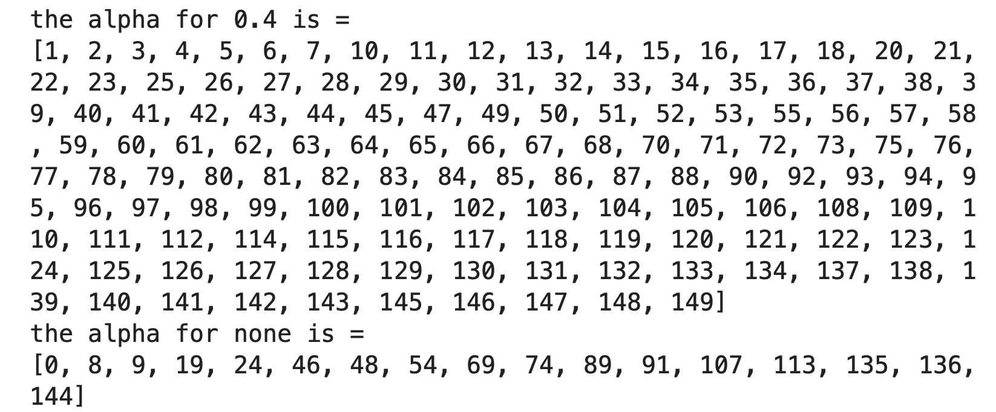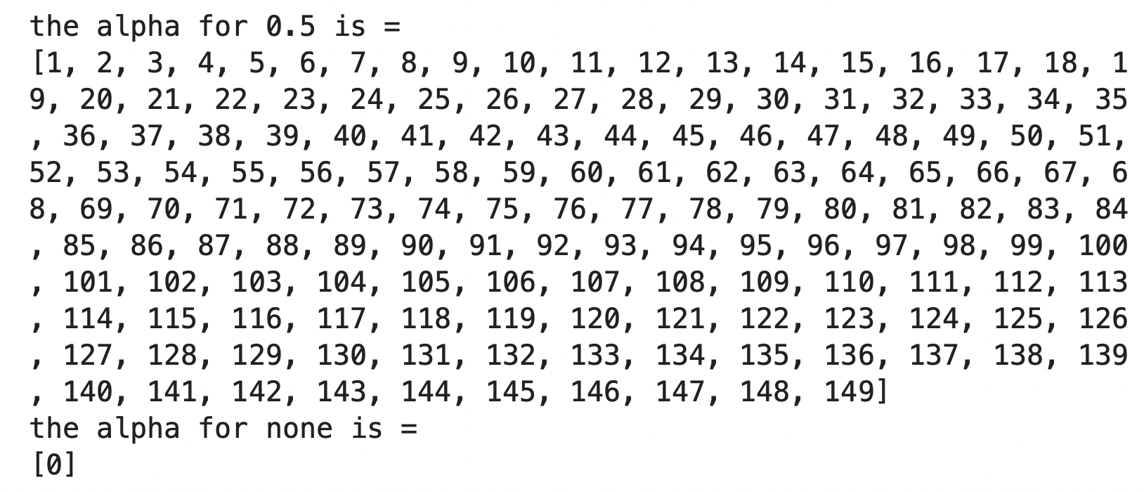

The cuts above are example of what the calcAlphacut function has created.